Michelle Bagnall

CITA 210

Assignment 3 Part 1 Screenshots

This is the output for converting 68 degrees to Celsius.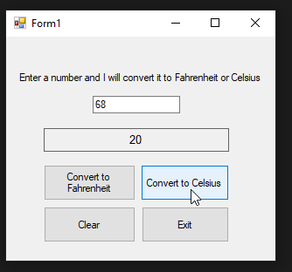

This is the output when converting 15 degrees to Fahrenheit.